 | SAKR MANNING AGENCY  FOR RECRUITING EGYPTIAN LABOR ABROAD | Issue Date | 15.05.2022
 |  | Revision Date | 19.07.2022
 | Crewing Management Manual  Seafarer Employment Application | Revision | 1.1
 |  | Page | 3
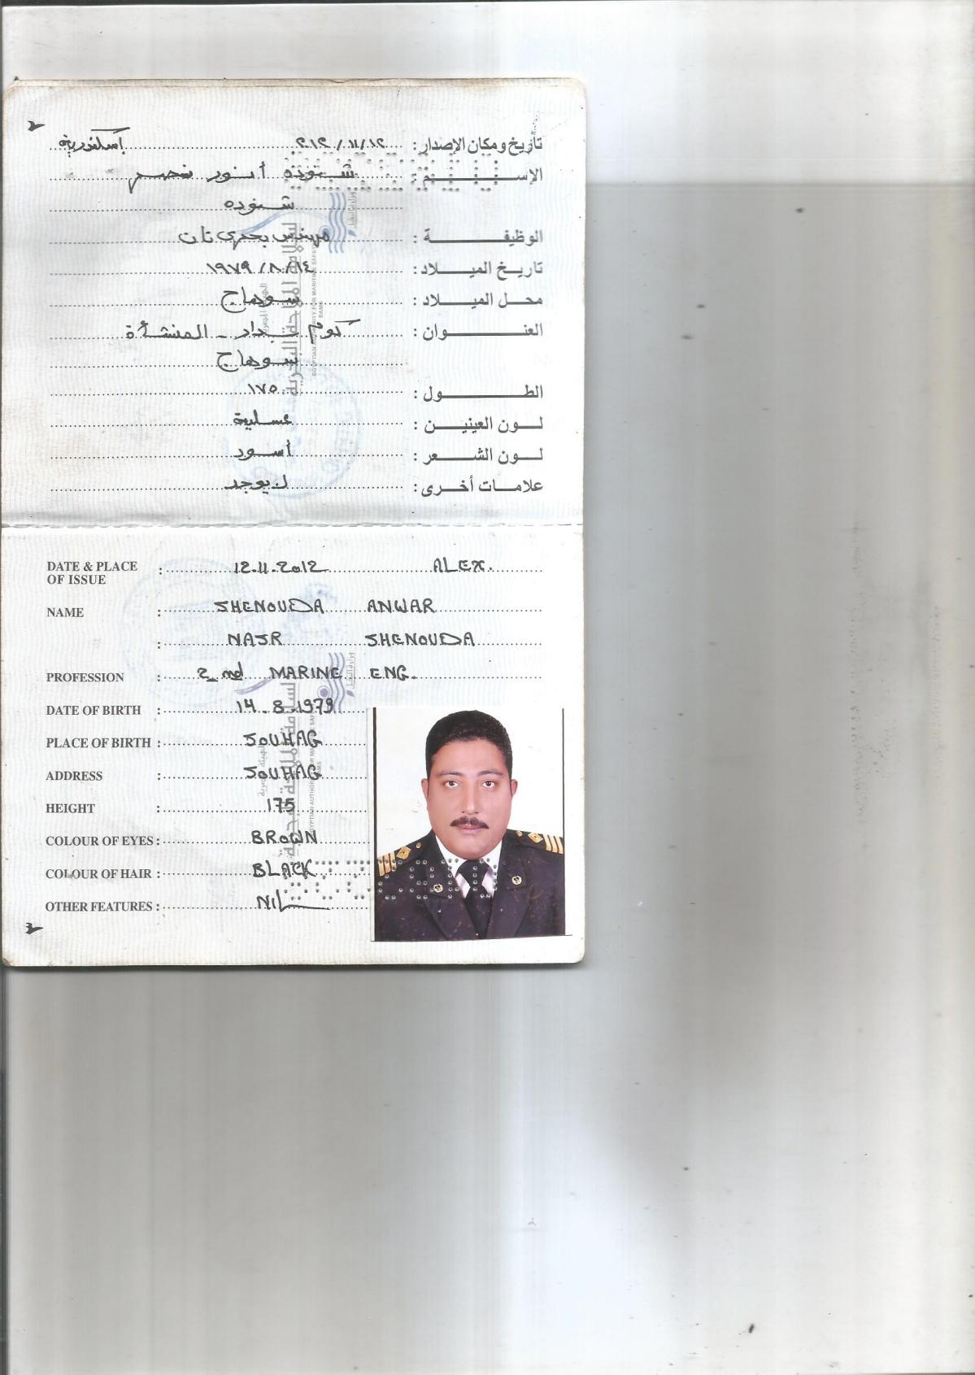
Application For Position as | 2ND ENGINEER
Register Code. | EO-2.014
Other Position (If Any) | NO
Register Date | 07/03/2023
Last up Date Data
Expected Salary

1. PERSONAL DETAILS
Full Name |  | Shenouda Anwar Nasr Shenouda
Date Of Birth |  | 14/08/1979 |  |  |  |  |  |  | Place Of Birth |  |  |  |  |  |  |  | SOHAG, EGYPT
Nationality |  | EGYPTIAN |  |  |  |  |  |  | Marital Status |  |  |  |  |  |  |  | Single |  |  |  |  |  |  |  | Married
Height (Cm) |  | 176 |  |  |  |  |  |  | Overall Size |  |  |  |  |  |  |  | XXL |  |  |  |  | Shirt Size |  |  |  |  |  | XL
Weight (Kg) |  | 95 |  |  |  |  |  |  | Trouser Size |  |  |  |  |  |  |  | 48 |  |  |  |  | Shoes Size |  |  |  |  |  | 45
2. EDUCATION
College / School |  | Arab Academy for Science, Technology & Maritime Transport
Marline Test |  | Issued Date |  |  |  |  | Result % |  |  |  | Issued By (Authority) |  |  |  |  |  |  |  |  |  | Issued At
English Language |  | Fluent |  |  |  |  |  | Good |  |  |  |  | Average |  |  |  |  |  |  |  | Poor
……… Language  ( ) |  | Fluent |  |  |  |  |  | Good |  |  |  |  | Average |  |  |  |  |  |  |  | Poor
3. CONTACT DETAILS
Home Address / City |  |  | EGYPT SOHAG KOUM BADAR
E-Mail |  |  | Sma.794@hotmail.com |  |  |  |  |  |  | Mobile / Tel |  |  |  |  |  | +201027076960

4. TRAVEL DOCUMENTS
Type |  | Document No. |  |  |  | ISS. Date |  |  | Exp. Date |  |  |  |  | ISS. By (Authority) |  |  |  |  |  |  |  |  |  | Place of Issue
Passport |  | A23002125 |  |  |  | 28/07/2018 |  |  | 27/07/2025 |  |  |  |  | Egyptian Authority |  |  |  |  |  |  |  |  |  | SOHAG
Seaman Book |  | S00016153 |  |  |  | 27/06/2021 |  |  | 07/06/2026 |  |  |  |  | EAMS |  |  |  |  |  |  |  |  |  | Alex.
Other Seaman Book |  | PA0215924 |  |  |  | 30/03/2022 |  |  | 07/06/2026 |  |  |  |  | PANAMA MARITIME AUTHORITY |  |  |  |  |  |  |  |  |  | PANAMA

5. PROFESSIONAL QUALIFICATION / CERTIFICATE OF COMPETENCY
Certificate Name |  |  |  |  | Number | Issue Date |  |  |  |  |  | Expiry Date |  |  |  |  |  | Issued By |  |  |  |  |  |  |  |  | Issued At
COC |  |  |  |  | 3882 | 27/06/2021 |  |  |  |  |  | 07/06/2026 |  |  |  |  |  | EAMS |  |  |  |  |  |  |  |  | Alex.
GOC |  |  |  |  |  |  |  |  |  |  |  |  |  |  |  |  |  | NTRA |  |  |  |  |  |  |  |  | Cairo
D.P. INDUCTION
D.P. ADVANCED
D.P. OPERATOR (UNLIMITED)
6. NEXT OF KIN
Full Name | ADELL ANWAR NASR |  |  |  |  |  |  |  |  |  |  |  |  |  | Relationship |  |  |  |  | BORTHER
Address | EGYPT SOHAG KOUM BADAR
Tel. No. |  |  |  |  |  |  |  |  |  | Mobile |  |  | +201222839110
7. HEALTH CERTIFICATES & VACCINATIONS
Flag State |  |  |  | Number |  |  | Issue Date |  |  |  |  | Expiry Date |  |  |  |  |  |  | Issued By |  |  |  |  |  |  | Issued At
International Medical |  |  |  | 11180 |  |  | 19/02/2023 |  |  |  |  | 18/02/2025 |  |  |  |  |  |  | EAMS |  |  |  |  |  |  | Alex.
Yellow Fever |  |  |  | XXXXXX |  |  | 11/11/2020 |  |  |  |  | XXXXX |  |  |  |  |  |  | Ministry of Health |  |  |  |  |  |  | ALEX
Cholera |  |  |  |  |  |  |  |  |  |  |  |  |  |  |  |  |  |  | Ministry of Health
Covid-19 |  |  |  | Vaccination Name |  |  | First Dose |  |  |  |  | Second Dose |  |  |  |  |  |  | (Other Does or Remarks)
 |  |  |  | PFIZER |  |  | 11/12/2021 |  |  |  |  | 09/01/2022

8. MARINE COURSES
Course Name | Number | Issue Date | Expiry Date | Issued By / At
Personal Survival Techniques
Proficiency In Personal Survival Techniques | 18983/21/EG | 09/06/2021 | 07/06/2026 | ALEX
Fire Prevention and Fire Fighting
Advanced Fire Prevention and Fire Fighting | 19417/21/EG | 13/06/2021 | 09/06/2026 | ALEX
Elementary First Aid | 20502/21/EG | 17/06/2021 | 16/06/2026 | ALEX
Medical Care Studies
Personal Safety and Social Responsibilities | 20415/21/EG | 17/06/2021 | 16/06/2026 | ALEX
Proficiency Of Security Awareness Training Seafarers | 19973/21/EG | 15/06/2021 | 13/06/2026 | ALEX
Proficiency as a ship Security officer ( PSSO )
Proficiency In Survival Craft & Rescue Boats | 20573/21/EG | 17/06/2021 | 14/06/2026 | ALEX
G.M.D.S.S
Communications
Advanced Communications
ECDIS Advanced Simulator (Management Level)
ECDIS Simulator (Operation Level)
Prevention and Combating of Marine Pollution | 44269/16/EG | 11/10/2016 | XXXXXX | ALEX
Radar & ARPA Simulator and Search &rescue
ARPA Simulator and Search
Marine Radar and automatic Radar Plotting
Bridge resource Management (B.R.M)
Engine resource Management (E.R.M) | 17957/21/EG | 02/06/2021 | XXXXXX | ALEX
Navigational Watch keeping
Proficiency for Rating forming part of Navigational watch (II/4) |  |  |  | EAMS / Alex.
High voltage training – operation of ship (1000 Volt and More)
Passenger Safety Cargo Safety and Hull integrity
Crowd Management Training
Crisis Management and Human Behavior Training
Safety training for Personal Prov. Direct Passengers
Practical Ability to Prepare Meals and (MLC 2006)
Personal Hygiene and Envir. Protection (MLC 2006)
Safety and Health in the Provision Meals (MLC 2006)
Food Storage and inventory Control (MLC 2006)
Ships Cook Certificate (MLC 2006) |  |  |  | EAMS / Alex.
Abel Seafarer Deck
Proficiency for Abel Seafarer Deck ( II/5 ) |  |  |  | EAMS / Alex.
Engineering Watch keeping |  |  |  | EAMS / Alex.
Proficiency for Rating forming part of a watch in engine room
Abel Seafarer Engine
Proficiency for Abel Seafarer Engine ( III/5 ) |  |  |  | EAMS / Alex.
Electro Technical Rating
Proficiency for Electro Technical rating ( III/7 ) |  |  |  | EAMS / Alex.
Attended Course in " ( Management Level 1 Refreshment Course Engineering Department | 19812/21/EG | 13/6/2021 | 9/6/2026 | ALEX
Satisfactory Completed " Refreshment in Advanced Training for Off Tanker Cargo Operation | 19171/21/EG | 9/6/2021 | 7/6/2026 | ALEX

COMPLETE SEA – SERVICE DETAILS

Name: | Shenouda Anwar Nasr Shenouda |  |  |  |  |  |  | Rank: |  |  | 2ND ENGINEER |  |  |  |  | Register Code: |  |  |  |  |  |  |  | EO-2.015
Company Name |  |  | Rank |  | Vessel Name |  |  |  | Signed On |  |  | Signed Off |  |  |  | Period |  |  | Vessel Type |  | D.W.T. |  |  |  |  | Engine Type |  |  | BH | KW
ORION MARITIME DMCC |  |  | 2ND ENG |  | PSS ENERGY  IMO : 9228813 |  |  |  | 03/03/2022 |  |  | 26/10/2022 |  |  |  | 7MONTH 23 DAYS |  |  | CHEMICAL SHIP |  | 37244 |  |  |  |  | MAN B&W 6S55MC-C MK7 |  |  | 8900HP | 6639.4
HANAN SHIPPING LLC |  |  | 2ND ENG |  | NAVARINO  IMO: 8806826 |  |  |  | 15/7/2021 |  |  | 15/10/2021 |  |  |  | 3MONTHS |  |  | CHEMICAL SHIP |  | 12700 |  |  |  |  | MAK8M551 |  |  | 6250HP | 4662.5
TOM NAVIGATION |  |  | 2ND ENG |  | AL ZAFARANA |  |  |  | 01/03/2021 |  |  | 01/07/2021 |  |  |  | 4MONTHS |  |  | TANKER SHIP |  | 21106 |  |  |  |  | SULZAR BN |  |  | 17800 HP | 13278.8
PYRAMID NAVIGATION CO ESA |  |  | 2ND ENG |  | AL NABILA 5  IMO : 8705618 |  |  |  | 06/08/2017 |  |  | 12/12/2017 |  |  |  | 3 MONTHS  18 DAYS |  |  | TANKER SHIP |  | 29027 |  |  |  |  | SULZAR 58 |  |  | 11700 HP | 8728.2
PYRAMID NAVIGATION CO ESA |  |  | 2ND ENG |  | AL NABILA 5  IMO : 8705618 |  |  |  | 03/12/2016 |  |  | 30/3/2017 |  |  |  | 4 MONTHS  27 DAYS |  |  | TANKER SHIP |  | 29027 |  |  |  |  | RTA |  |  | 11700 HP | 8728.2
PYRAMID NAVIGATION CO ESA |  |  | 2ND ENG |  | AL NABILA 5  IMO : 8705618 |  |  |  | 03/03/2016 |  |  | 13/7/2016 |  |  |  | 4 MONTHS  16 DAYS |  |  | TANKER SHIP |  | 29027 |  |  |  |  | SULZAR 58 |  |  | 11700 HP | 8728.2
PYRAMID NAVIGATION CO ESA |  |  | 2ND ENG |  | AL NABILA 5  IMO : 8705618 |  |  |  | 02/06/2015 |  |  | 25/10/2015 |  |  |  | 4 MONTHS |  |  | TANKER SHIP |  | 29027 |  |  |  |  | RTA |  |  | 11700 HP | 8728.2
PYRAMID NAVIGATION CO ESA |  |  | 2ND ENG |  | AL NABILA 5  IMO : 8705618 |  |  |  | 30/10/2014 |  |  | 09/4/2015 |  |  |  | 6 MONTHS  9 DAYS |  |  | TANKER SHIP |  | 29027 |  |  |  |  | SULZAR 58 |  |  | 11700 HP | 8728.2
PYRAMID NAVIGATION CO ESA |  |  | 2ND ENG |  | AL NABILA 5  IMO : 8705618 |  |  |  | 16/1/2014 |  |  | 09/07/2014 |  |  |  | 7 MONTHS  25 DAYS |  |  | TANKER SHIP |  | 29027 |  |  |  |  | RTA |  |  | 11700 HP | 8728.2
PYRAMID NAVIGATION CO ESA |  |  | 2ND ENG |  | AL NABILA 5  IMO : 8705618 |  |  |  | 30/12/2012 |  |  | 21/10/2013 |  |  |  | 10 MONTHS  21 DAYS |  |  | TANKER SHIP |  | 29027 |  |  |  |  | SULZAR 58 |  |  | 11700 HP | 8728.2
PYRAMID NAVIGATION CO ESA |  |  | 2ND ENG |  | AL NABILA 5  IMO : 8705618 |  |  |  | 01/06/2010 |  |  | 05/11/2010 |  |  |  | 5 MONTHS  11 DAYS |  |  | TANKER SHIP |  | 29027 |  |  |  |  | RTA |  |  | 11700 HP | 8728.2
PYRAMID NAVIGATION CO ESA |  |  | 3ND ENG |  | AL SHARIFA 4 |  |  |  | 01/06/2010 |  |  | 05/11/2010 |  |  |  | 5 MONTHS  11 DAYS |  |  | TANKER SHIP |  | 52875 |  |  |  |  | RND |  |  | 13700 HP | 10220.2
PYRAMID NAVIGATION CO ESA |  |  | 3NDENG |  | AL NABILA 5  IMO : 8705618 |  |  |  | 15/10/2009 |  |  | 23/4/2010 |  |  |  | 7 MONTHS  3 DAYS |  |  | TANKER SHIP |  | 29027 |  |  |  |  | SULZAR 58  RTA |  |  | 11700 HP | 8728.2
PYRAMID NAVIGATION CO ESA |  |  | 3ND ENG |  | LUKA |  |  |  | 15/1/2009 |  |  | 14/8/2009 |  |  |  | 7 MONTHS |  |  | TANKER SHIP |  | 50840 |  |  |  |  | SULZAR 58 |  |  | 13750 HP | 10257.5
PYRAMID NAVIGATION CO ESA |  |  | 3ND ENG |  | LUKA |  |  |  | 01/08/2008 |  |  | 30/10/2008 |  |  |  | 3 MONTHS |  |  | TANKER SHIP |  | 50840 |  |  |  |  | SULZAR 58 |  |  | 13750 HP | 10257.5
SPECIALISED EXPERIENCE
Name |  |  |  |  |  |  |  |  |  | Type |  |  |  | From |  |  | To |  |  |  |  | Comments
I declare that the information I have given is, to the best of my knowledge, true and complete. I also declare that the documents submitted are genuine, given and sign by persons whose names appear on them.
 |  |  |  |  |  |  |  |  |  |  |  |  | 05/03/2023 |  |  |  |  |  |  |  |  |  | SHENOUDA ANWAR
 |  |  |  |  |  |  |  |  |  |  |  |  |  |  | DATE |  |  |  |  |  |  |  |  |  | SIGNATURE

